REPORT ON FEEDBACK RECEIVED FROM ALUMNIES

- A questionnaire was prepared to make a survey on various parameters of Government Dental College and Hospital, Ahmedabad and same was filled by the alumni of the college in the year 2021-2022.
- The questionnaire consisted of 10 questions which were based primarily on attributes of curriculum/syllabus, facilities provided,syllabus covered, aspects covered beyond curriculum, etc. Alumnies were asked to rate each question in 1 to 10 scale. In the given survey held in 2021-2022, GDCH, Ahmedabad collected feedback from alumnies.
- The responses were analyzed in order to take corrective actions in relation to institutional vision and mission.
- The elaborative questionnaire along with its evaluation is given below:

- ENTIRE SYLLABUS COVERED AS PRESCRIBED BY THE UNIVERSITY

The given chart shows the percentage of respondents. 39% of alumni rated excellent,61% alumni reported as good about the time adequacy provided for the completion of course.
- THE CONTENT OF THE COURSE WAS RELEVANT

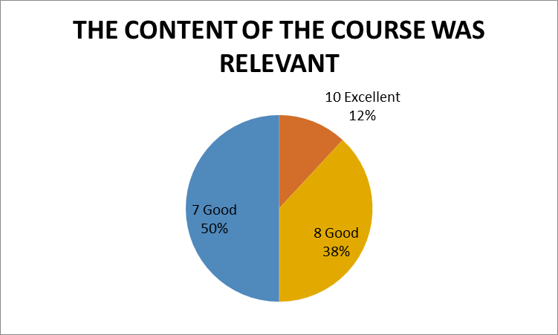
The given chart shows the percentage of respondents. 12% of alumni rated excellent,88% Alumnireported as good about the relevance of the content of the course.

- ABILITY TO INTEGRATE TOPICS BEYOND CURRICULUM TO PROVIDE A BROADER PERSPECTIVE FOR CAREER ENHANCEMENT

The given chart shows the percentage of respondents. 31% of Alumnirated excellent,62% Alumnireported as good and 7 % average about the ability to integrate topics beyond curriculum

- WHEN YOU MEET A STUDENT WHO HAS UNDERGONE SIMILAR PROGRAM FROM OUTSIDE THE INSTITUTE, YOUR PROGRAM WAS SUPERIOR/ INFERIOR IN TERMS OF THEORETICAL/ CLINICAL CONTENT
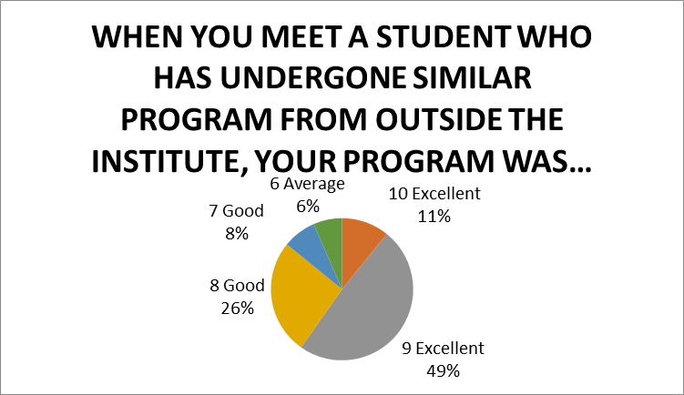
The given chart shows the percentage of respondents. 60% of alumni rated excellent,34% alumni reported as good and 6% of them reported average about the superiority of our program in relation.

- FACILITIES PROVIDED IN TERMS OF INFRASTRUCTURE& AUDIOVISUAL AIDS
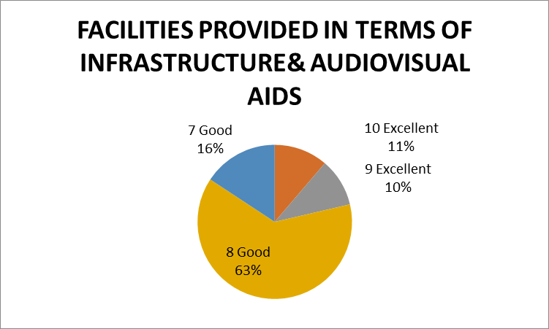
The given chart shows the percentage of respondents. 21% of alumni rated excellent,79% alumni reported as good about the facilities provided in terms of infrastructure and audiovisual aids

- AVALABILITY BEYOND NORMAL CLASSES AND CO-OPERATION TO SOLVE INDIVIDUAL PROBLEMS
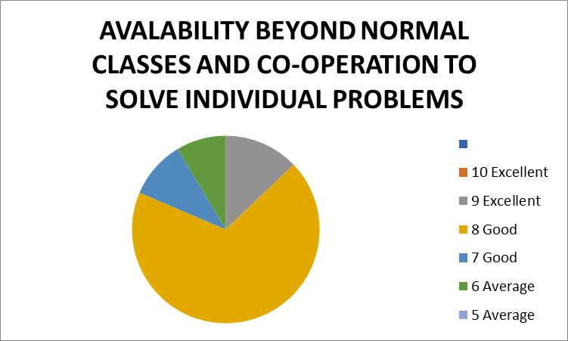
The given chart shows the percentage of respondents. 19% of Alumni rated excellent,15% alumni reported as good and 11 % as average about the availability of beyond normal classes and cooperation to solve individual problems.

- KNOWLEDGE GAINED AFTER COMPLETION OF COURSE

The given chart shows the percentage of respondents. 95% of Alumni rated excellent,37% alumni reported as good and 7% of them reported average about the knowledge gained after completion of course.

- FAIRNESS IN EVALUATION IN ASSESSMENT/INTERNALS

The given chart shows the percentage of respondents. 30% of Alumni rated excellent,63% Alumni reported as good and 7% of them reported average about the fairness in evaluation in assessment/ internals.

- AVAILABILITY OF RECENT TRENDS IN THE INSTITUTE
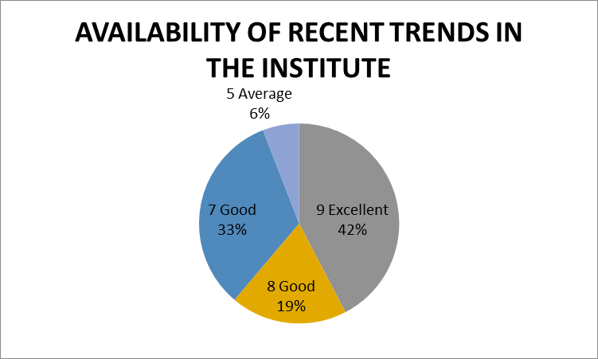
The given chart shows the percentage of respondents. 42% of alumni rated excellent,52% alumni reported as good and 6% of them reported average about the availability of recent trends in institute.

- TIME ADEQUACY PROVIDED FOR THE COMPLETION OF COURSE
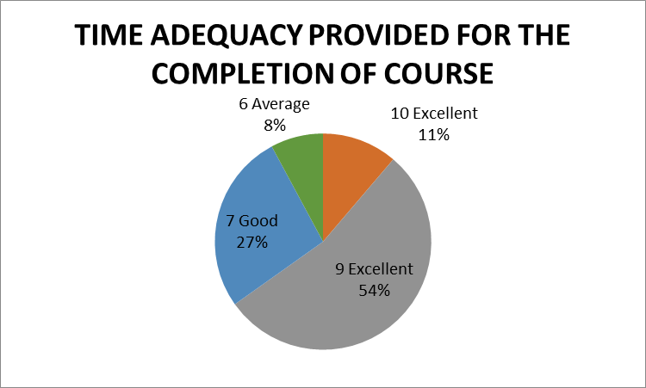
The given chart shows the percentage of respondents. 65% of alumni rated excellent,27% alumni reported as good and 8% of them reported average about the time adequacy provided for the completion of course.

