REPORT ON FEEDBACK RECEIVED FROM ALUMNIES

- A questionnaire was prepared to make a survey on various parameters of Government Dental College and Hospital, Ahmedabad and same was filled by the alumni of the college in the year 2020-2021.
- The questionnaire consisted of 10 questions which were based primarily on attributes of curriculum/syllabus, facilities provided,syllabus covered, aspects covered beyond curriculum, etc. Alumnies were asked to rate each question in 1 to 10 scale. In the given survey held in 2020-2021, GDCH, Ahmedabad collected feedback from alumnies.
- The responses were analyzed in order to take corrective actions in relation to institutional vision and mission.
- The elaborative questionnaire along with its evaluation is given below:

- ENTIRE SYLLABUS COVERED AS PRESCRIBED BY THE UNIVERSITY

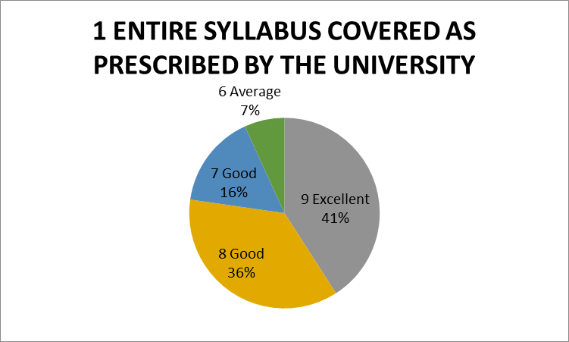
The given chart shows the percentage of respondents. 41% of alumni rated excellent, 52% alumni reported as good and 7% of them reported average about the time adequacy provided for the completion of course

- THE CONTENT OF THE COURSE WAS RELEVANT
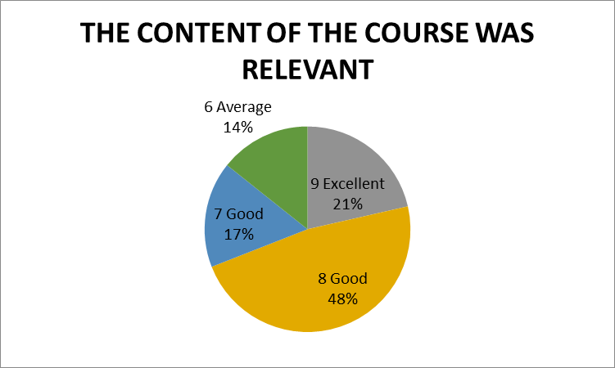
The given chart shows the percentage of respondents. 21% of alumni rated excellent, 65% Alumnireported as good and 14% as average about the relevance of the content of the course.

- ABILITY TO INTEGRATE TOPICS BEYOND CURRICULUM TO PROVIDE A BROADER PERSPECTIVE FOR CAREER ENHANCEMENT
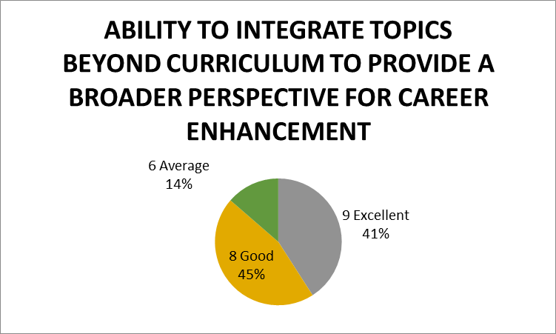

The given chart shows the percentage of respondents. 41% of faculty rated excellent,45% students reported as good average and 14% as average about the ability to integrate topics beyond curriculum

- WHEN YOU MEET A STUDENT WHO HAS UNDERGONE SIMILAR PROGRAM FROM OUTSIDE THE INSTITUTE, YOUR PROGRAM WAS SUPERIOR/ INFERIOR IN TERMS OF THEORETICAL/ CLINICAL CONTENT
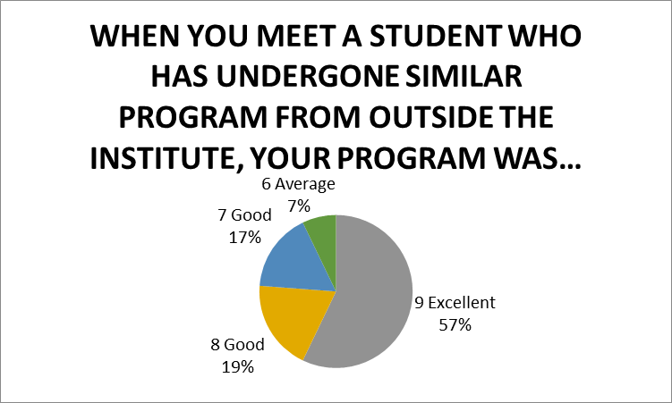
The given chart shows the percentage of respondents. 57% of alumni rated excellent,36% alumni reported as good and 7% of them reported average about the superiority of our program in relation

- FACILITIES PROVIDED IN TERMS OF INFRASTRUCTURE& AUDIOVISUAL AIDS
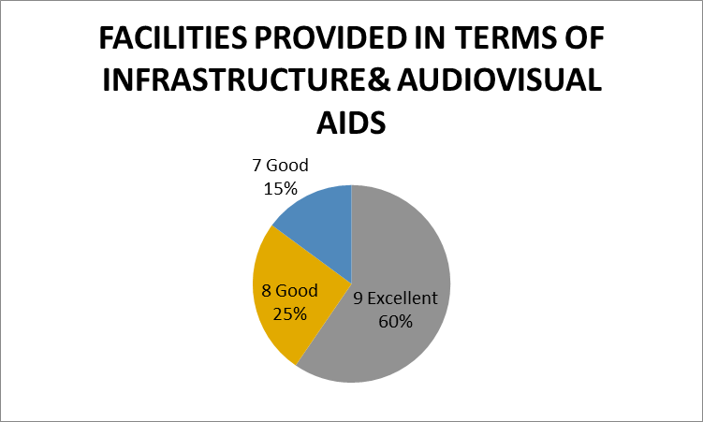

The given chart shows the percentage of respondents. 60% of alumni rated excellent,40% alumni reported as good about the facilities provided in terms of infrastructure and audiovisual aids

- AVALABILITY BEYOND NORMAL CLASSES AND CO-OPERATION TO SOLVE INDIVIDUAL PROBLEMS
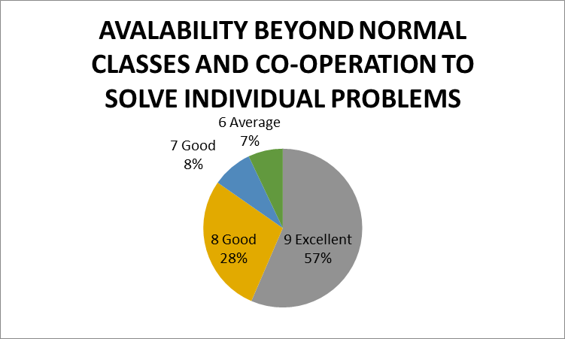

The given chart shows the percentage of respondents. 57% of Alumnirated excellent,36% alumni reported as good and 7% as average about the availability of beyond normal classes and cooperation to solve individual problems.

- KNOWLEDGE GAINED AFTER COMPLETION OF COURSE
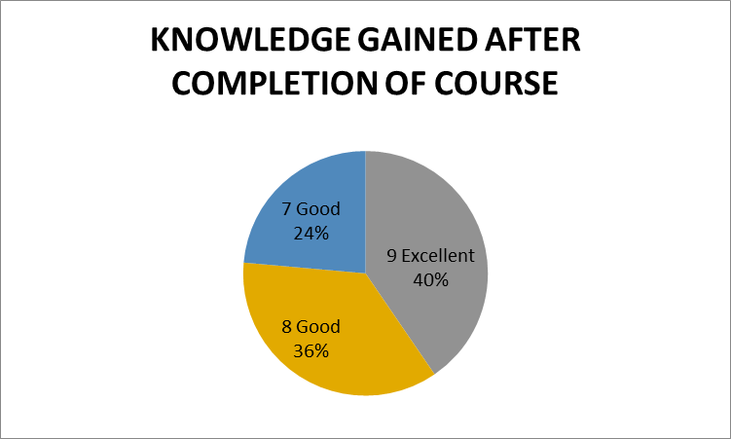
The given chart shows the percentage of respondents. 40% of Alumnirated excellent,60% alumni reported as good about the knowledge gained after completion of course.

- FAIRNESS IN EVALUATION IN ASSESSMENT/INTERNALS
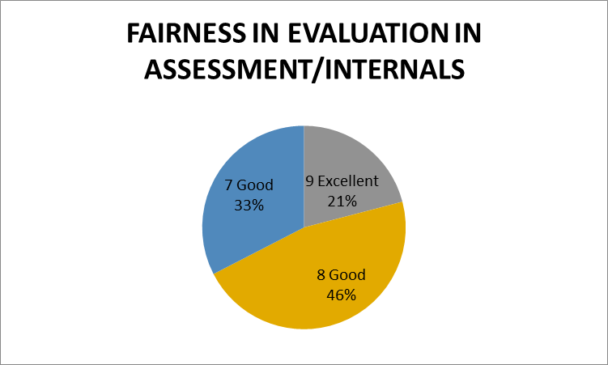
The given chart shows the percentage of respondents 79% reported as good and 21% of them reported excellent about the fairness in evaluation in assessment/ internals.

- AVAILABILITY OF RECENT TRENDS IN THE INSTITUTE
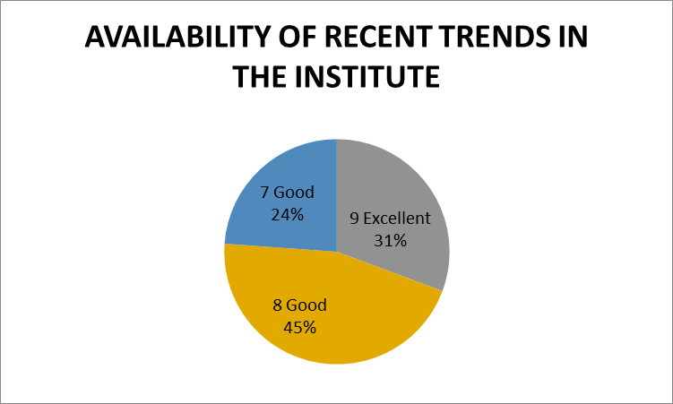
The given chart shows the percentage of respondents. 31% of alumni rated excellent,69% alumni reported as good about the availability of recent trends in institute.

- TIME ADEQUACY PROVIDED FOR THE COMPLETION OF COURSE
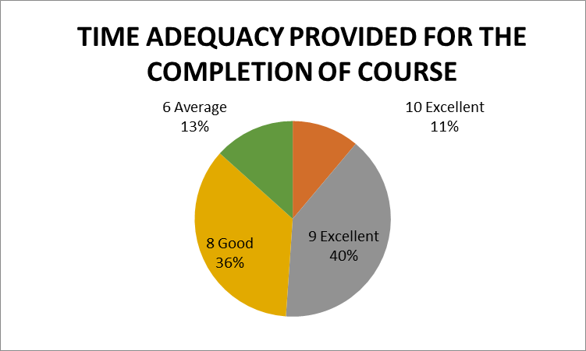
The given chart shows the percentage of respondents. 51% of alumni rated excellent,36% alumni reported as good and 13% of them reported average about the time adequacy provided for the completion of course.

