REPORT ON FEEDBACK RECEIVED FROM ALUMNAE

- A questionnaire was prepared to make a survey on various parameters of Government Dental College and Hospital, Ahmedabad and same was filled by the alumnae of the college in the year 2018-2019.
- The questionnaire consisted of 10 questions which were based primarily on attributes of curriculum/syllabus, facilities provided, syllabus covered, aspects covered beyond curriculum, etc. Alumnae were asked to rate each question in 1 to 10 scale. In the given survey held in 2018-2019, GDCH, Ahmedabad collected feedback from alumnae.
- The responses were analyzed in order to take corrective actions in relation to institutional vision and mission.
- The elaborative questionnaire along with its evaluation is given below:

- ENTIRE SYLLABUS COVERED AS PRESCRIBED BY THE UNIVERSITY

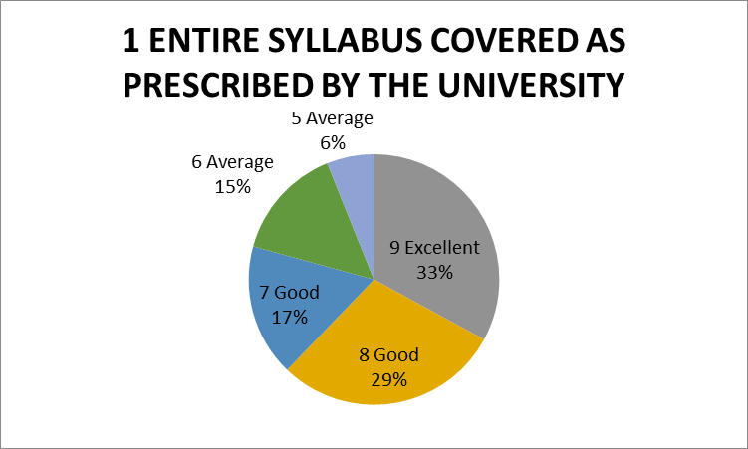
The given chart shows the percentage of respondents. 33% of alumni rated excellent, 46% alumni reported as good and 21% of them reported average about the time adequacy provided for the completion of course.

- THE CONTENT OF THE COURSE WAS RELEVANT
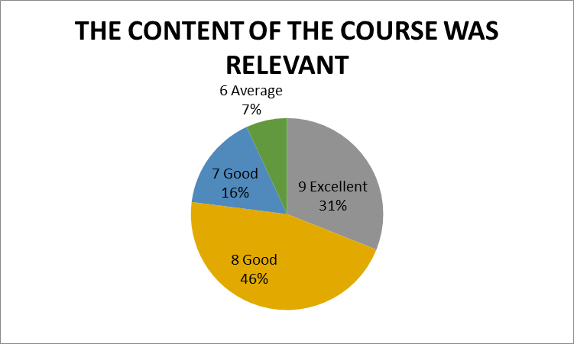
The given chart shows the percentage of respondents. 31% of alumni rated excellent, 62% rated good and 7% alumni reported as average about the relevance of the content of the course.

- ABILITY TO INTEGRATE TOPICS BEYOND CURRICULUM TO PROVIDE A BROADER PERSPECTIVE FOR CAREER ENHANCEMENT
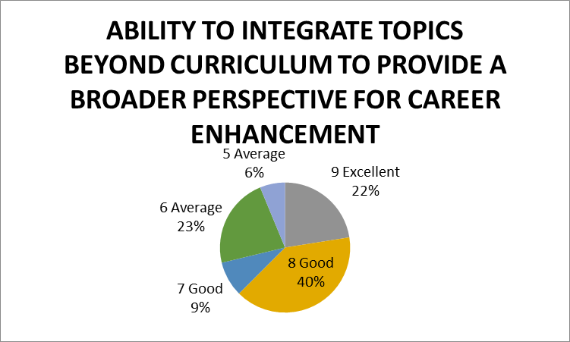
The given chart shows the percentage of respondents. 22% of Alumni rated excellent, 49% alumni reported as good and 29% average about the ability to integrate topics beyond curriculum.
- WHEN YOU MEET A STUDENT WHO HAS UNDERGONE SIMILAR PROGRAM FROM OUTSIDE THE INSTITUTE, YOUR PROGRAM WAS SUPERIOR/ INFERIOR IN TERMS OF THEORETICAL/ CLINICAL CONTENT
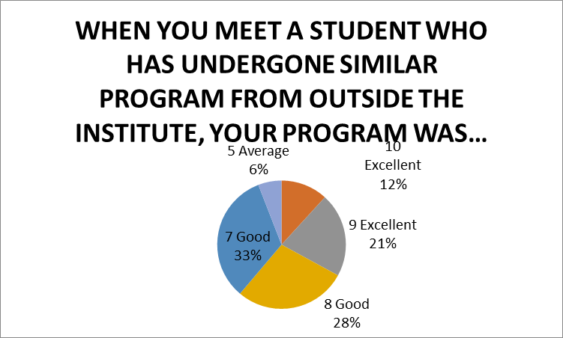
The given chart shows the percentage of respondents. 33% of alumni rated excellent,61% alumni reported as good and 6% of them reported average about the superiority of our program in relation
- FACILITIES PROVIDED IN TERMS OF INFRASTRUCTURE& AUDIOVISUAL AIDS
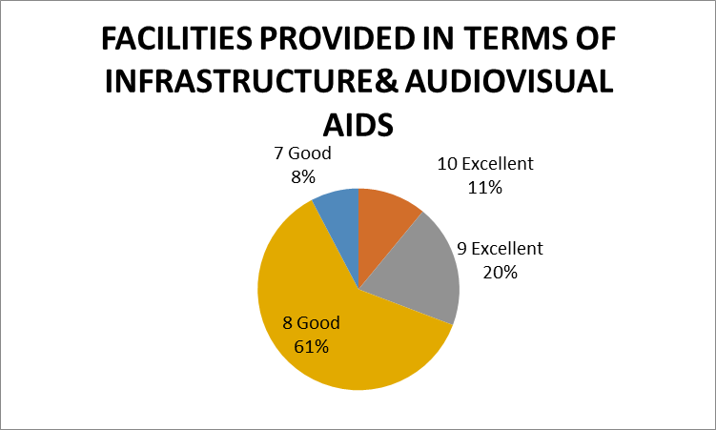
The given chart shows the percentage of respondents. 31% of alumni rated excellent,69% alumni reported as good about the facilities provided in terms of infrastructure and audiovisual aids.

- AVALABILITY BEYOND NORMAL CLASSES AND CO-OPERATION TO SOLVE INDIVIDUAL PROBLEMS
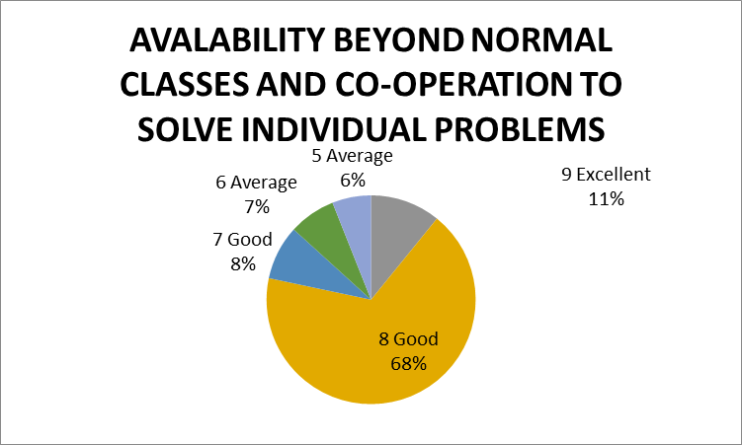
The given chart shows the percentage of respondents. 11% of Alumnirated excellent,76% alumni reported as good and 6% average about the availability of beyond normal classes and cooperation to solve individual problems.

- KNOWLEDGE GAINED AFTER COMPLETION OF COURSE
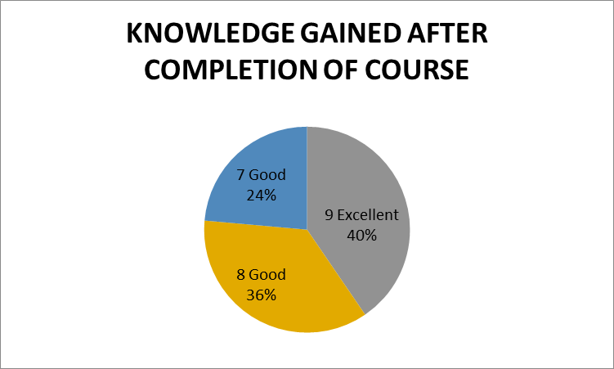
The given chart shows the percentage of respondents. 40% of faculty rated excellent,60% alumni reported as good about the knowledge gained after completion of course.

- FAIRNESS IN EVALUATION IN ASSESSMENT/INTERNALS
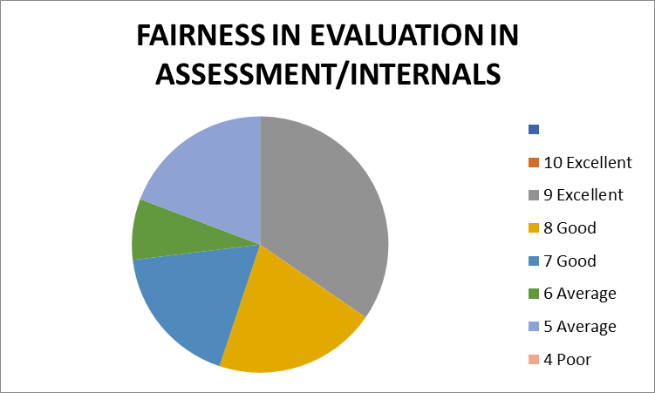
The given chart shows the percentage of respondents reported 19% as excellent and 15% of them reported good and 11% average about the fairness in evaluation in assessment/ internals.
- AVAILABILITY OF RECENT TRENDS IN THE INSTITUTE
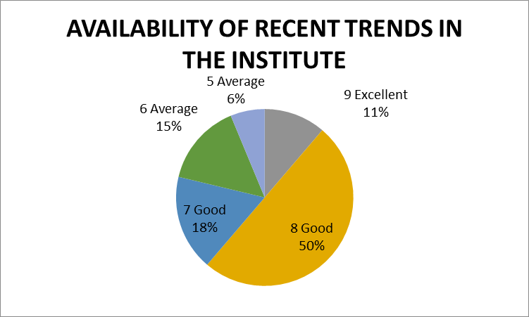
The given chart shows the percentage of respondents. 11% of alumni rated excellent,68% alumni reported as good and 21% of them reported average about the availability of recent trends in institute.

- TIME ADEQUACY PROVIDED FOR THE COMPLETION OF COURSE
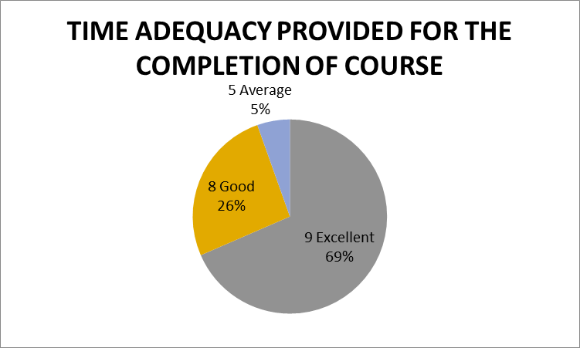
The given chart shows the percentage of respondents. 69% of alumni rated excellent,26% alumni reported as good and 5% of them reported average about the time adequacy provided for the completion of course.

